- When single conventional tillage implement is used

Draft prediction equation
$$D=F\left\{A+B\left(S\right)+C\left(S\right)2\right\}W\left(\frac{T}{10}\right)$$
Where:
D: Implement Draft Force, N
F : Dimensionless soil texture adjustment parameter (1 for fine, 2 for medium, 3 for coarse)
A, B, C: Machine-specific parameters (dependent on implement type and soil)
S : Field speed, km/h
W: Machine width, m
T : Tillage depth, cm

The drawbar power (DB_{p}) required to pull any tillage implement was computed as:
DB_{p} = D × S (3.4)
where D = draft, kN
S = speed of operation, m/s
Tractive performance prediction
tractive efficiency (TE)
(3.2)
P_{st} = μR_{r} (3.3)
where μ = coefficient of traction
μ_{g} = gross traction ratio
S = wheel slip (fraction)
R_{r} = rear wheel dynamic weight
However, the maximum pull developed (P_{et}) based on the engine torque could be given as:
(3.4)
where F = thrust developed due to engine torque
MR = motion resistance
T = engine torque
r = rolling radius of driving wheel
η_{ea} = transmission efficiency between engine and axle of tractor
ρ_{r} = coefficient of rolling resistance of the rear wheel of tractor
ρ_{f} = coefficient of rolling resistance of the front wheel of tractor
R_{r} = rear axle dynamic weight
R_{f} = front axle dynamic weight

Tractor dynamic weight calculation
The dynamic weight on tractor axles required for predicting tractive performance was computed from the force analysis of free body diagram of the tractor-implement system as shown in Fig. …..

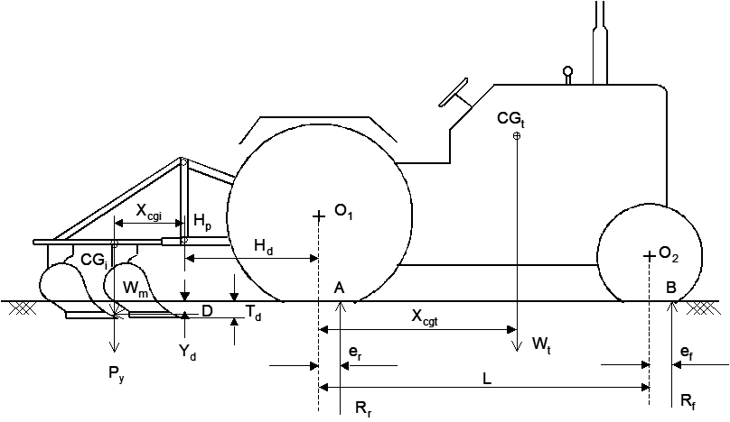

Fig. …….Free body diagram of tractor-implement combination.

Taking moment of forces about point ‘B’, the dynamic weight on tractor rear axle was calculated by the following equation:
(3.5)
Hence, the dynamic weight on tractor front axle could be expressed by:
(3.6)
where W_{t} = weight of tractor acting at CG_{t}
W_{m} = weight of implement acting at CG_{i}
X_{cgi} = horizontal distance of CG of implement from tractor hitch point H_{p}
H_{d} = horizontal distance of tractor hitch point from the rear axle center
L = wheel base
P_{y} = vertical component of soil force and was calculated considering the average P_{y}/D ratio as mentioned by Kepner et al. (1978)…..
(Use this ratio Py/D as 0.15 for Moldboard plough. 0.40 for disk plough, 0.50 for disc harrow and 0 for cultivator)
X_{cgt} = horizontal distance of CG of tractor from the center of rear axle
Y_{d} = , depth at which draft acted (assumed)…. Td is depth of operation
e_{r} = rear wheel eccentricity
= ρ_{r} r_{r} (Liljedahl et al., 1996)… use = ρ_{r} = 0.1
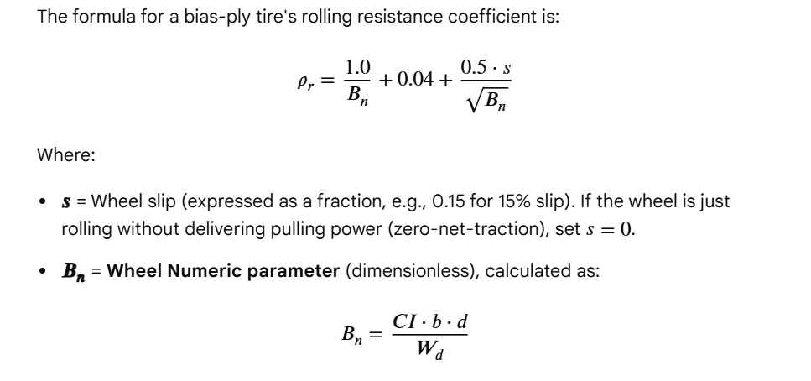
CI = Cone Index of the soil
b =tire section width
d = overall tire diameter (m or mm).
W_{d} = Dynamic vertical load on the rear tire

r_{r} = rolling radius of the rear wheel of tractor
e_{f} = front wheel eccentricity
= ρ_{f} r_{f} (Liljedahl et al., 1996)
r_{f} = rolling radius of the front wheel of tractor (to be added in tractor database)
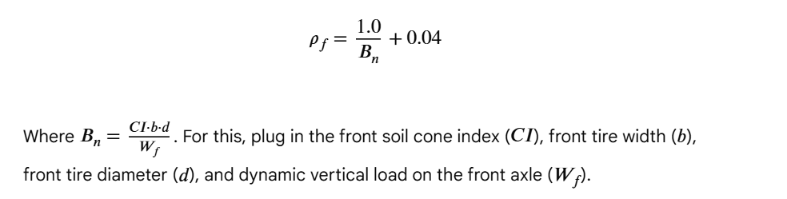
Ballast requirement at the front axle of tractor
The minimum front axle weight utilization factor (K_{wef} = R_{f}/W_{t}) was considered as 0.2 for proper steering control and stability of the tractor-implement system (Habarata, 1971; Horton and Crolla, 1984). When K_{wef} was less than 0.2, ballast requirement at the front axle of tractor (BR_{f}) was calculated using the following expression to maintain the front axle weight utilization factor as 0.2.
(3.7)
where R_{sf} = static weight on the front axle of tractor

Ballast requirement of the rear axle of tractor
The ballast requirement at the rear axle of tractor (BR_{r}) for reducing slip to 15% was calculated using the following expression:
(3.8)
where
(3.9)
where R′ = dynamic weight required at tractor rear axle for S = 0.15
R_{sr} = static weight on the rear axle of tractor
µ′ = coefficient of traction at S = 0.15 and B_{n} = B_{n}′
B_{n}′ = mobility number at W=R′/2 (Eq. 2.4) and S = 0.15

Tractor power utilization equation
The required PTO power (P_{tr}) to pull an implement at any selected soil and operating conditions was computed from the drawbar power using the following expression:
(3.11)
where, η_{t} = transmission efficiency between PTO and axle of tractor
The power utilization of a tractor (P_{ut}) for a particular operation was computed using the expression as given below:
(3.12)
where, P_{tr} = required PTO power for a particular operation, and
P_{t} = rated PTO power of a tractor
f_{s} = power reserve (0.2)
Check Put value and display message as given below
Sl No | P_{ut} | Message to be displayed
1 | between 95 to 100%, | Tractor is properly loaded
2 | less than 95% | Tractor is Underloaded
3 | more than 100% | Tractor is Overloaded

- When combi tillage implement is used

There are two possibilities, Passive passive or passive active combination

Passive-passive combi tillage
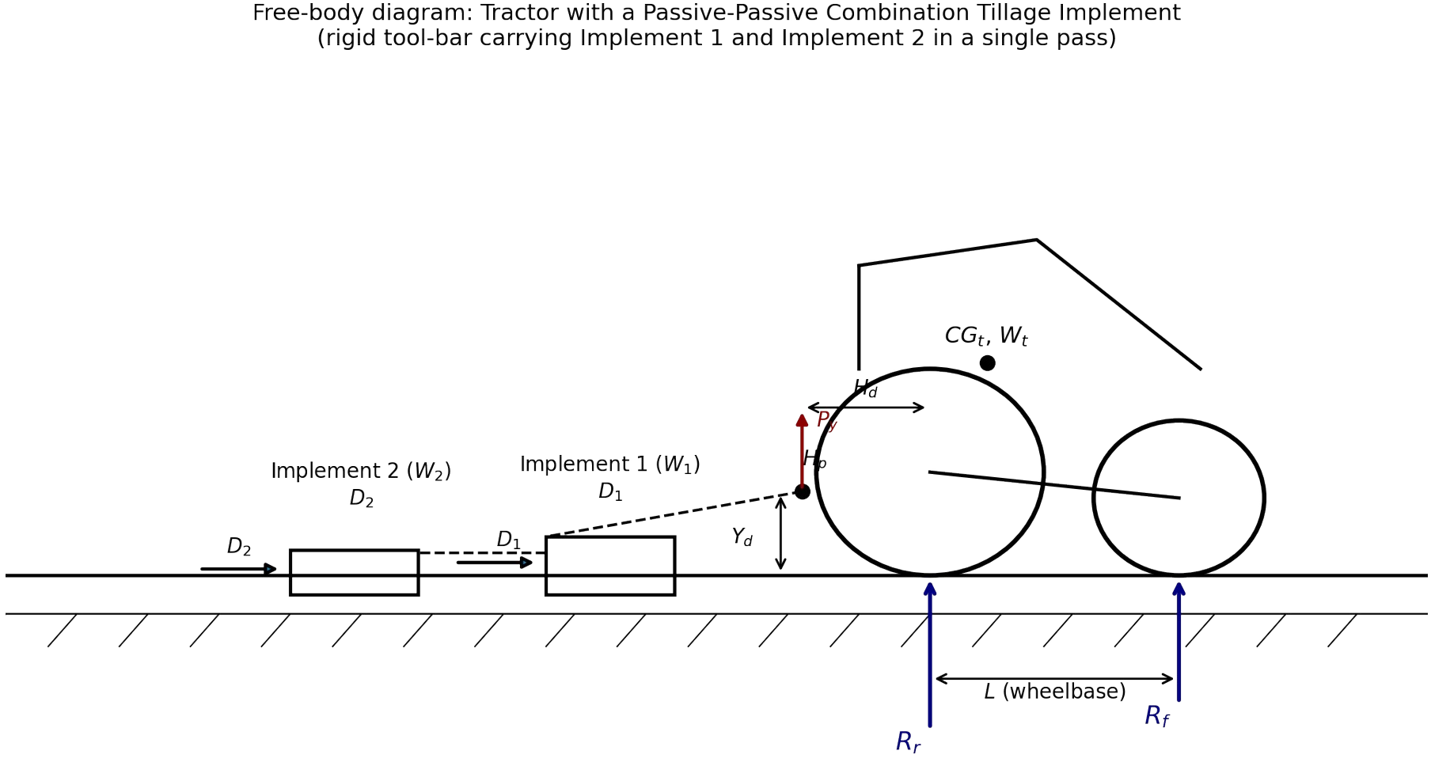
Fig. 1. Free-body diagram of a tractor coupled to a passive–passive combination tillage implement. Both tools (weights W1 and W2, drafts D1 and D2) are carried on a common rigid tool-bar attached at the hitch point Hp.

W1 and W2 are implement weight, W1 and W2 acting at their respective centres of gravity; the vertical soil reaction Py acting at the hitch; the horizontal draft forces D1 and D2 acting at depth Yd below the surface; and the dynamic ground reactions Rr and Rf at the rear and front wheels respectively
Combined draft —
The interaction coefficient ki is determined experimentally for a given tool pair, soil type, and depth setting, and typically lies in the range:
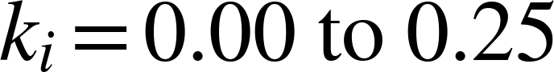

with ki → 0 when the trailing tool works well outside the loosened zone of the leading tool (e.g., wide lateral offset) and ki → 0.25 for tools that fully overlap the loosened band at shallow relative depth.

Dynamic axle loads — moment-balance derivation

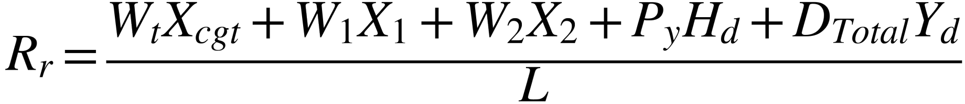

The dynamic front-axle load then follows directly from vertical force equilibrium of the whole tractor–implement system:
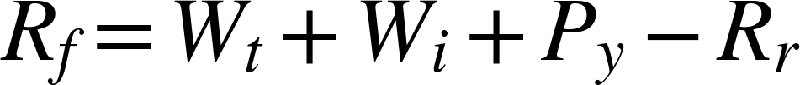

where the total implement weight is
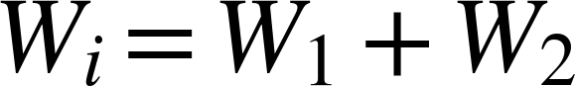

Ballast requirement

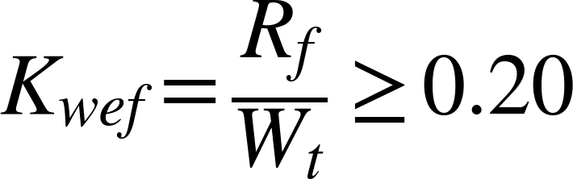

When Kwef < 0.20, the front ballast BRf required to restore Kwef = 0.20 is obtained by re-solving the moment-balance equation (Eq. 4.6/4.7 with the added ballast weight at the front axle) for BRf:
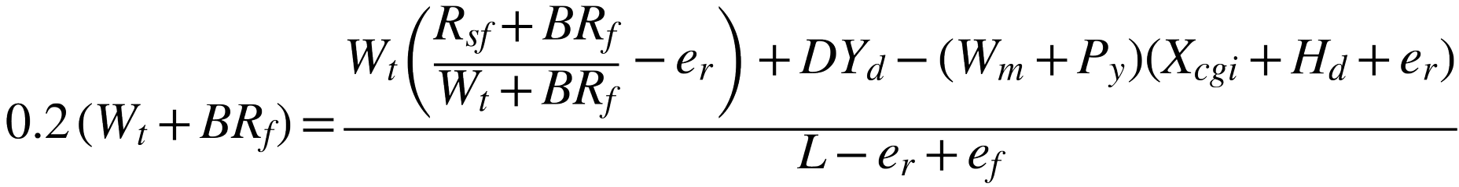
Similarly, the rear ballast BRr required to limit wheel slip to 15% is obtained by requiring the dynamic rear-axle load to equal the value R′ needed to develop the design pull at S = 0.15 (Section 4.6):
with DTotal used in place of D in both R′ (Eq. 3.9 of Section 3.4) and in Eq. (4.8)–(4.9) above.

Tractive performance of the passive–passive combination
Because the two towed tools do not add any powered thrust, the tractive-performance sub-model of Section 3.4.5 (Brixius traction equations) applies unchanged, with DTotal in place of D. The wheel-numeric (mobility number), gross traction ratio, and coefficient of traction at trial slip S are computed iteratively exactly as in the single-tool DSS algorithm:
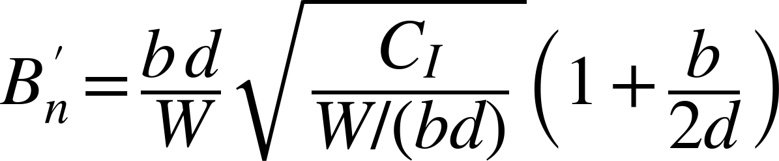

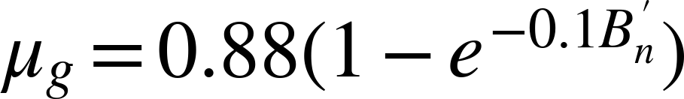

and the tractive efficiency and pull developed are, as before,

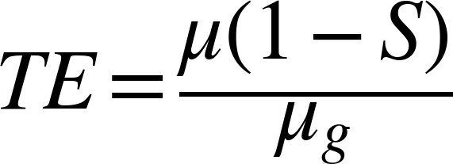

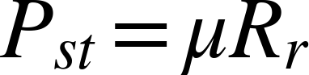

The trial slip is increased in increments of 0.1% (starting from an assumed 2%) until Pst ≥ DTotal, in the same manner as the flow chart of Section 3.4.6 (Fig. "Flowchart for the simulation module of DSS").

Power utilization and fuel consumption
The drawbar power, PTO power required, and power-utilization factor follow directly from Eq. 3.4, 3.11 and 3.12 of Section 3.4.5, with DTotal in place of D:
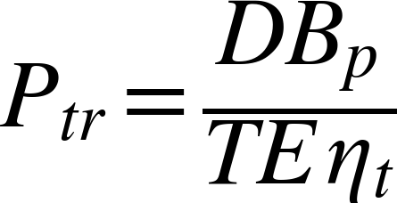

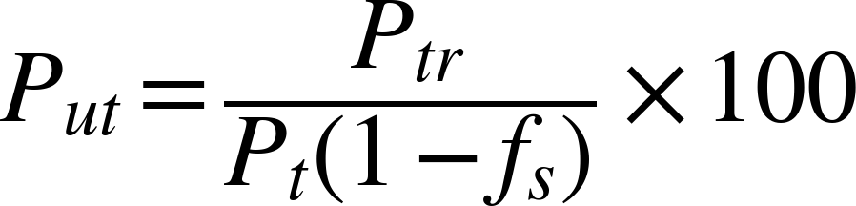

and specific fuel consumption from the ASABE Standards fuel-consumption equation (ASAE, 2001):

Because DTotal(1−ki) is, in practice, appreciably smaller than D1+D2, both Ptr and hence FC are reduced relative to the sum of the two independent passes — this is quantified for a specific tool pair in the worked example of Section 7.2.

- CASE II — ACTIVE + PASSIVE COMBINATION

Free-body diagram
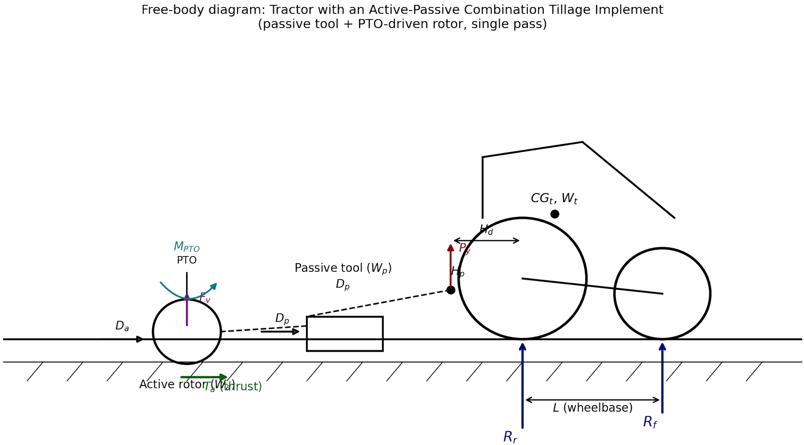

Fig. 2. Free-body diagram of a tractor coupled to an active–passive combination tillage implement. The passive tool (weight Wp, draft Dp) and the PTO-driven active rotor (weight Wa) together generate a forward thrust Ta, a PTO reaction moment MPTO, and a dynamic vertical force Fv, in addition to the mechanical (frame/bearing) resistance Da of the rotor.

Effective draft of the combination
The net horizontal resistance that the tractor must overcome (the effective draft) is the sum of the passive tool's draft and the active rotor's own mechanical resistance, reduced by whatever forward thrust the rotor develops:

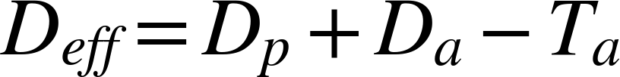

The forward thrust Ta
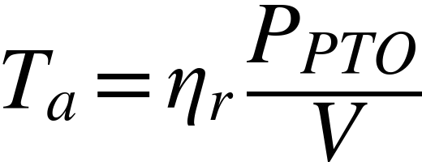

Substituting Eq. (5.2) into Eq. (5.1) gives the working equation for effective draft used throughout the remainder of this chapter:
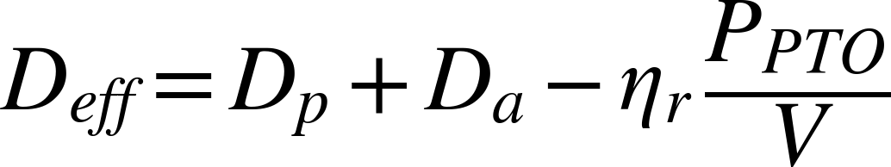

The rotor efficiency ηr is a tool-specific coefficient (typically 0.25–0.45 for rotary pulverizers, higher for tools with a more favourable rake angle) … Let us give the user choice of selecting value between 0.25 to 0.45

PTO torque reaction moment

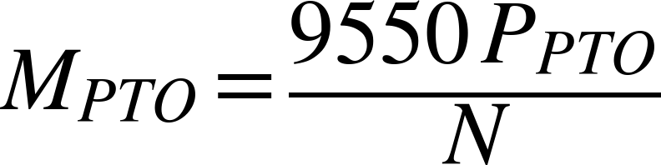

it is converted to an equivalent additional vertical force at the rear axle by dividing by the wheelbase (L),
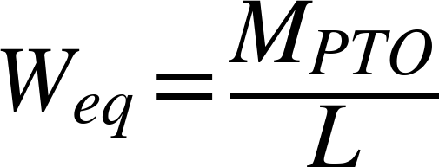

and this equivalent load is added directly to the rear-axle dynamic weight computed from the ordinary force/moment balance of Section 5.6:
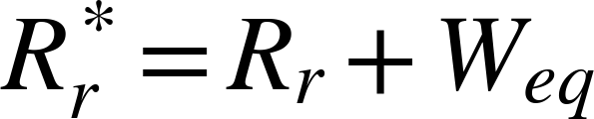

Complete moment-balance equations for the active–passive combination
Combining Sections 5.3–5.6, the full dynamic rear- and front-axle loads for the active–passive combination, in the same practical (simplified-eccentricity) form adopted for Eq. (4.7) of the passive–passive case, are:

where Wp and Xp are the weight and CG offset of the passive tool, and Wa and Xa are the corresponding quantities for the active rotor unit. Comparing Eq. (5.7) with the passive–passive result of Eq. (4.7) shows that the active–passive case differs by exactly the two additional terms MPTO/L and Fv — confirming that

Section 4's equations are the special case of Section 5's equations obtained by setting PPTO = 0 (and hence Ta = MPTO = Fv = 0).

Ballast requirement for the active–passive combination
The front-axle weight-utilization criterion is applied exactly as before, but with Rf now given by Eq. (5.7b):
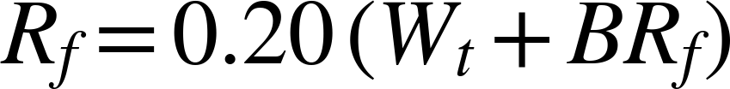

Solving for the required front ballast BRf when the as-designed Rf falls short of this target:
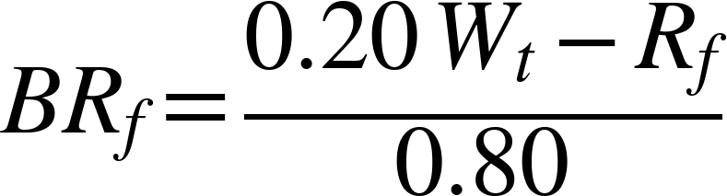

For the rear axle, the ballast required to develop the pull needed to overcome the effective draft — rather than merely to hold slip at 15% as in Section 4.5, since an active rotor can substantially change the slip at which a given pull is developed — is obtained by first computing the dynamic weight required at the rear axle to develop a pull equal to Deff at the operating coefficient of traction μ(S):
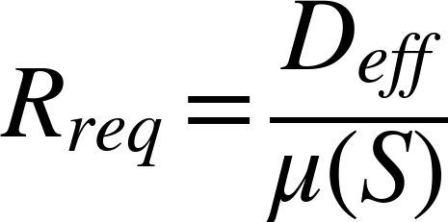

and then comparing this requirement with the as-designed (or as-computed) rear-axle load from Eq. (5.7a):
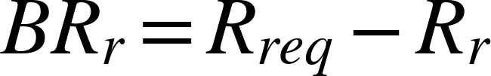

A negative value of BRr (i.e., Rr already exceeds Rreq) indicates that the active rotor's own thrust and reaction-moment contributions have supplied sufficient additional rear-axle loading that no further rear ballast is necessary — a possibility that does not arise for a purely passive combination and is one of the principal practical advantages of an active–passive design identified in this chapter.

Rotor power, combined traction equation, and power utilization
The mechanical power delivered by the rotor, expressed through its torque T and rotational speed N, is:
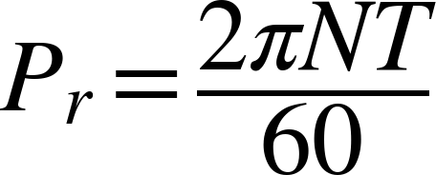

and the equivalent horizontal force that this rotor power represents, at the prevailing forward speed V, is:
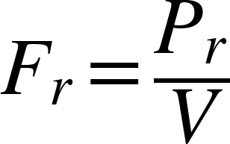

Fr, so computed, directly replaces part of the tractor's own draft requirement — it is, in fact, an alternative (torque-based) route to the same thrust term Ta introduced in Eq. (5.2), and the two should agree when ηr is back-calculated from a measured torque and speed. For overall tractive-power bookkeeping, the combined traction (total resistance to be overcome by the tractor's tractive effort) is written generally as:
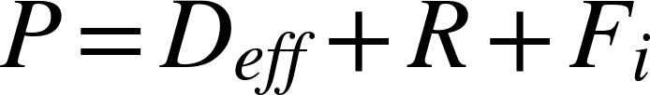

where R is ordinary rolling resistance of the tractor's own wheels and Fi is any additional inertial resistance associated with acceleration of the implement mass (normally negligible at steady forward speed, but retained for completeness in transient/turning conditions). The power-utilization factor of the tractor must now include both the drawbar-equivalent power and the directly delivered PTO power, since both are drawn from the same engine:
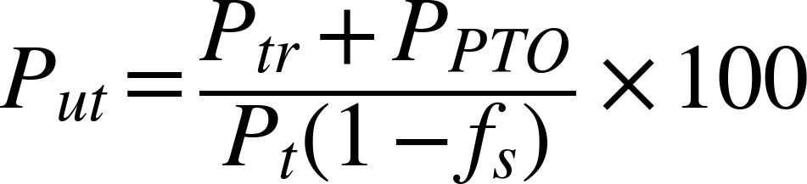

and the effective PTO-power ratio used in the fuel-consumption equation becomes:

